# Introduction

## Purpose

### General Purpose

The current world was faced with a pandemic of COVID-19. That virus is extremely infectious and is transmitted by airdrome droplets. So, the government and people should organize some restrictions to prevent the mass spreading of coronavirus.

One of the most visited places in the real-world is shops and stores. They cannot be closed because people have to purchase essential goods, such as food. So, there should be a way to provide a low chance of transmitting the virus to new people. As the World Health Organization established the maximum range of the effective virus spreading (1.5 meters) it could be used to estimate the optimal flow in the store concerning the security. However, it makes another trouble: people who are waiting outside a store making a crowd enhancing the chance of obtaining and spreading the virus.

### Goals

G1: The system should provide customers with a reasonably precise estimation of the waiting time and should alert them taking into account the time they need to get to the shop from the place they currently are;

G2: To give people opportunity to stay in queue remotely to avoid crowds in stores and in real queues.

G3: Stores should have the possibility to hand out “tickets” on the spot;

G4: The system should allow customers to book a visit to the supermarket to optimize quantity of people in it by time of their visit, and category of products which they want to purchase;

Additional goals for the group of 3 members:

G5: The system (application and “tickets” on the spot) should include alternative slots (for another day), suggest to the customer the location of the nearest “safe” store based on his location;

G6: The system should allow the third party to get the statistical information to perform better management of the store.

## Scope

The service ‘‘Clup’’ (stands for Customers line up) gives the possibility to plan your visit to a shop with coordination with the management of a store (call them the third side). The application creates a virtual queue instead of a real one, helping to avoid crowds. Also, the system enables the personnel of the management to monitor a situation in a store. For including a store into the application, the manager should accommodate the service with information about areas of a store and departments (to calculate the maximum people flow).

Clup allows customer three options: to simply stand in the queue (the shortest waiting time), to book your visit for the time/day chosen by you, and to accept a token from a machine right outside a store (of course it is not recommended, but in case of not knowing about the application it is the only way). After picking any option users could enter a supposed time of a visit and choose the goods categories, to balance human flow between departments to get the best efficiency.

The location of a customer is getting by GPS, the location of the store is provided by the manager of the shop.

If the user is choosing the first option, the service shows him/her an estimated time of waiting and an estimated time of walking/driving to a store. After coming to a shop customer scans the QR code and if the time for a visit is not expired (came not more than some minutes late) user could go in and start to buy what he/she needs. The application also has an additional feature which will give the possibility to detect customers who not wearing masks it happens when the server gets the data from entering the store. If the user does not have a mask, he will be banned for some time. After exiting from the store user is popping out from the virtual queue.

The second option adding the notification feature to the first one. So, a customer gets the message when the planned visit time is coming. The rest functionality is inherited from the first option.

If a person is using a mobile device to stand in queue/book a visit he can see a load of stores to choose the one with the minimum waiting time/people flow. Also, it is possible to cancel a booking if a user changed his/her mind.

The third option presumes that a customer does not know about mandatory using the application to get in a store. So, when a person comes, he got a ticket with the time of a visit. This request is adding to the queue such as it will be a request from the first option. To visit/leave the store a customer has to scan his ticket before arrival/departure.

### The world:

* Stores are located at different places;
* Departments are located differently at each store;
* Stores and departments come in different sizes;
* Users can visit different stores and various departments in every store;
* Users purchase various products;
* Users choose basket based on the number of products they want to purchase;
* Users go from home to the store.

### Shared phenomena:

* Booking;
* User arrival time;
* User departure time;
* The wearing mask fact;
* Store and department area;
* Customer queue

A diagram containing world phenomena and shared phenomena is shown in Figure 1:

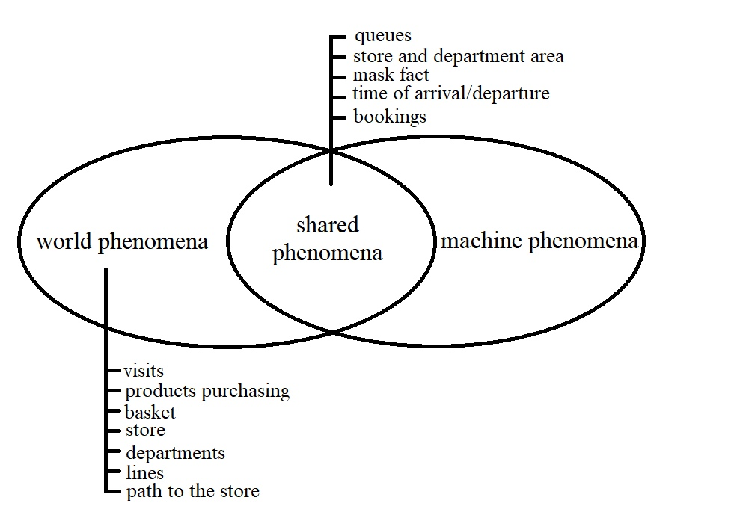

Fig 1: diagram of world phenomena & shared phenomena

## Definitions, **Acronyms**, Abbreviations

### Definitions

### **Acronyms**

**UML** – Unified Modeling Language.

### Abbreviations

## Revision History

## Reference Documents

## Document Structure